5th-7th Grade Supply List

Homeroom | ELA | Math | Social Studies/Science
1 book bag (rolling book bags are not recommended)  1 pencil pouch (no box)  1 pack of erasers  1 box black whiteboard markers  1 box color whiteboard markers  Black fine tip Sharpie permanent marker  1 roll of clear tape  3 boxes of tissues  1 Lysol wipe  2 rolls paper towel  2 Mr. Clean Magic erasers  1 pack of quart size Ziploc bags (girls only)  1 pack of gallon size Ziploc bags (boys only)  1 box colored pencils  1 box color marker  1 clear or black plastic folder (labeled Communications)  1 headphone labeled with name  1 pair of children’s blunt scissors  1 liquid glue (small) | 1 ream of copy paper  1 pack of blue pens  1 pack of 24 no. 2 pencils  1 yellow highlighter  1-inch binders (labeled ELA)  3 lined composition notebooks (labeled ELA)  1 yellow plastic folder with two pockets and prongs (labeled ELA)  1 pack of lined paper  1 pack post-it notes  1 pack of plastic sleeves  5 pack tabs  1 pack mini post it  1 flash drive | 1 ream of copy paper  1 pack of red pens  1 pack of 24 no. 2 pencils  1 blue highlighter  1 grid notebook (labeled Math)  1 blue plastic folder with two pockets (labeled Math)  1 pack grid paper  1 pack index card with lines  1 pack post-it notes  1 protractor  1 12-inch ruler  3 black whiteboard markers  1 pack playing cards  1 1-inch book ring  1 4-function Calculator (ONLY 7th GRADE)  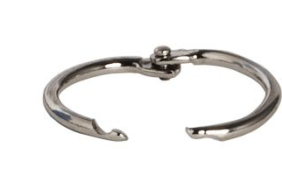 | 1 ream of copy paper  1 pack of 24 no. 2 pencils  1 purple highlighter  1 green highlighter  1-inch binders (labeled Social Studies)  1 lined composition notebook (labeled Social Studies)  1 lined composition notebook (labeled Science)  1 green plastic folder with two pockets and prongs (labeled Science)  1 red plastic folder with two pockets and prongs (labeled Social Studies)  1 pack of lined paper  1 pack of plastic sleeves

